Feed Alhambra
Drive-Through Food Distribution
110 S. 2nd Street, Alhambra
August 29, 2020 10:00 AM to 2:00 PM
(Please follow signs, obey traffic laws, and do not block traffic)

To ensure the health and safety of the volunteers and the community, we must adhere to the COVID-19 CDC guidelines. Please remain in your car and open your trunk when it is your turn in line.
___________________________________
Food distribution is first come, first serve while supplies last.

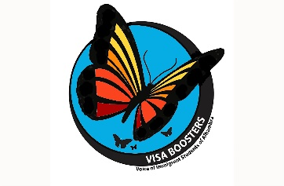
ORGANIZERS

DONORS
